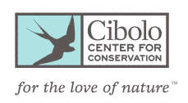
Cibolo Spring Break Camp
Counselor In Training Volunteer Application
Ages 13-16

Please email this completed application to nlawrence@cibolo.org

Name:
Your Email:
Parent/Guardian Name:
Parent/Guardian Email:
Parent/Guardian Cell Phone:
Street Address:
City:
State:
Zip:
Age:
Birthday:
Grade entering in the fall 2022:
School you will attend in the fall 2022:
T-shirt size:

Short Answer Questions
Why do you think it is important for children to have outdoor experiences and be comfortable in nature?

Why do kids look up to adults?

Why do you want to be a counselor in training at Cibolo Nature Camp or Art Camp?

Spring Break Camp Week:

Nature Camp
March 13-March 15 8:00am-2:00pm

Art Camp
March 13-March 15 1:00am-5:00pm

